Stirling Young Curlers
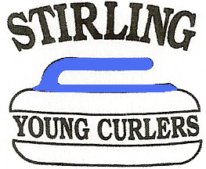
Clothing:
Warm layers, but not restrictive.
No jeans or sharp buckles etc. (track suit bottoms)
Clean trainers or similar (not used outside).
Long hair tied back.

Equipment:
Stones are provided.
Brushes are provided.
Sliders & grippers are available to borrow but must be returned at the end of each session. In time members may wish to supply their own. Curling shoes are not recommended for new members.

Fees:
Ice Fees of £xxx paid at door before session starts.
A Club Subscription of £xxx is payable on the fourth week of attendance.
RCCC membership is required, Fees annually £xxx
RCCC Award scheme- £xxx payable only if award is obtained.

Session Times:
Parents should make sure that their children have breakfast before leaving home.
All members to be at the Ice Rink at 8.15 ready for an 8.30 start.
Junior break app 9.30, snack and drink required (not Fizzy)
Junior session finishes about 10.30. Members and parents should wait until any announcements have been made before leaving.
A raffle is held at the end of each session, the proceeds going towards prizes at Christmas and end of season.

Attendance:
Within a few weeks of joining the new members will be playing in teams in Club competitions it is therefore important that they attend regularly to ensure that they do not let their team down. If it is known that they will be unable to attend on a particular date please record this in the attendance folder.

Emergencies:
In the event of a fire or other emergence within the Peak the Fire Alarm will sound and all members are to leave the equipment where it is and stand by the side of the Ice sheet as directed by the Coaches. The Peak staff will come and direct members and coaches to the correct exit and the muster points.
The Peak Staff have a responsibility for all first aid within the Centre. In the event of an accident the Coaches will call for the duty first aid officer.

Child Protection:
The Club’s Child Protection Officer is xxxxxxxxxxxxxxxxxxxxxxxxxxx
The Peak also has their own Child Protection Policy.

